GOPIKA ANILRAJ

a. Create a patient pf with fields patient id, Patient name , attending doctors id ,patient entry date , patient notes suggesting patients illness/problems

id should be key.

\*\*FOR PATIENT NOTES -- FIELD NAME PAILMENT

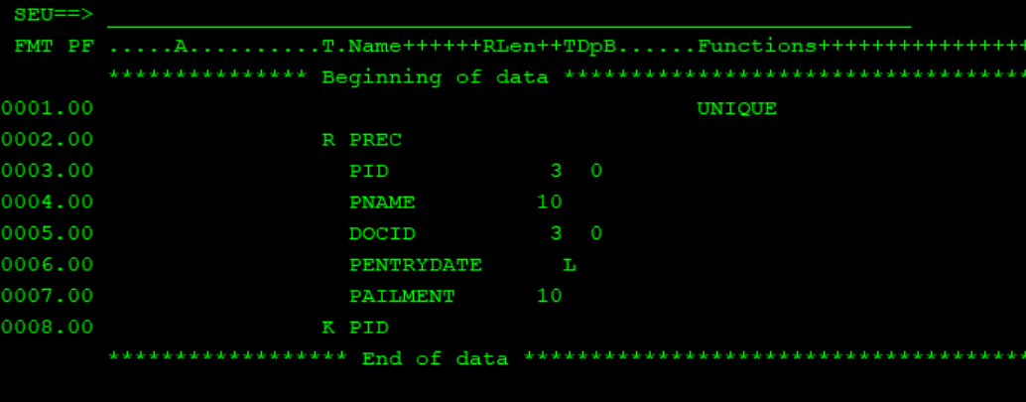

b. Create rpgle program to get patient id , name and ailment from screen and write into patient pf , patient entry date should always be current date.

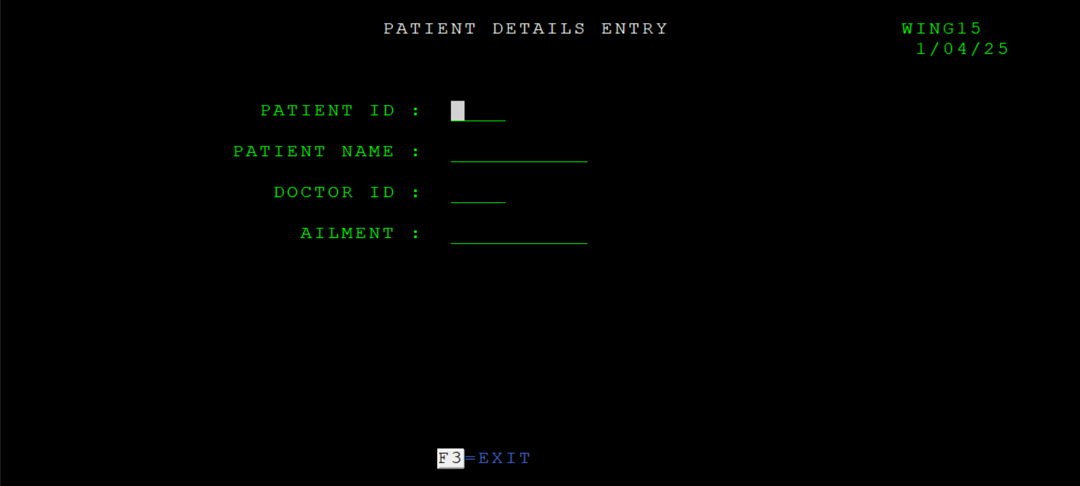

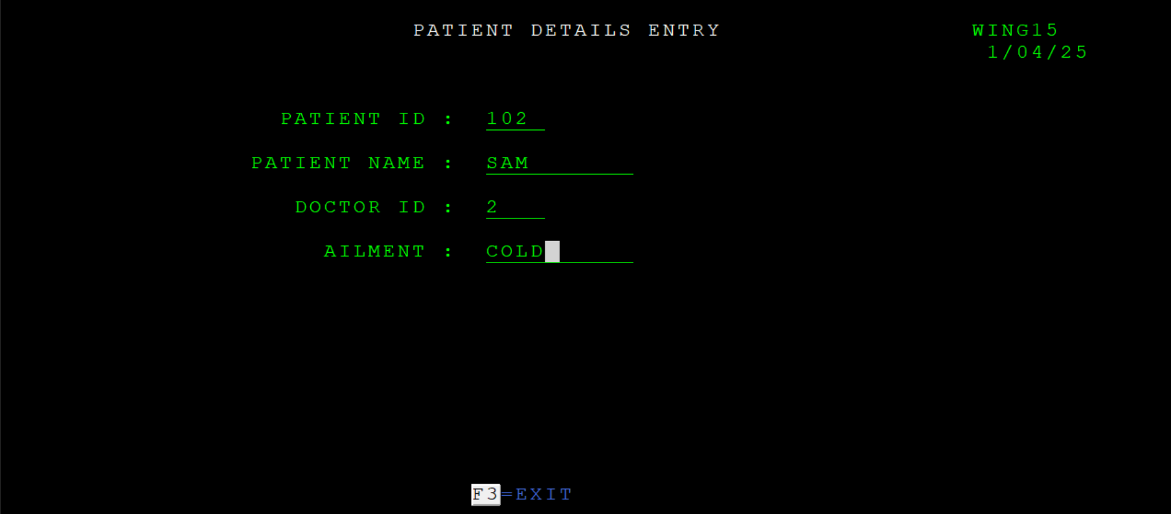

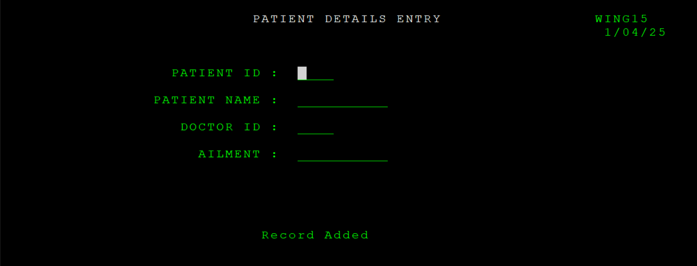

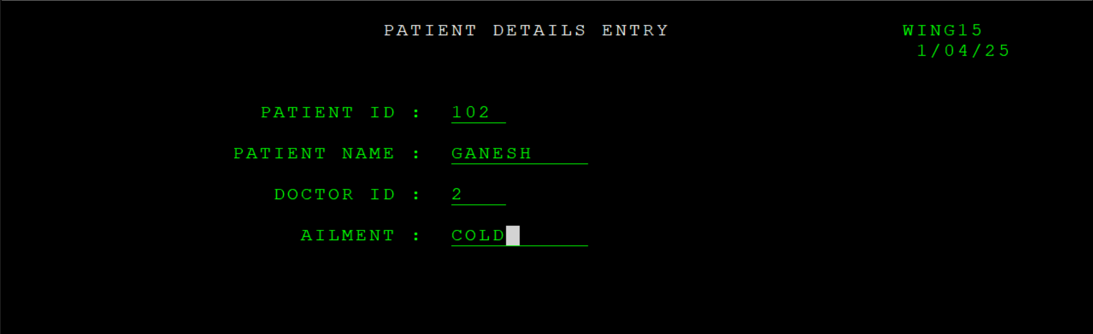

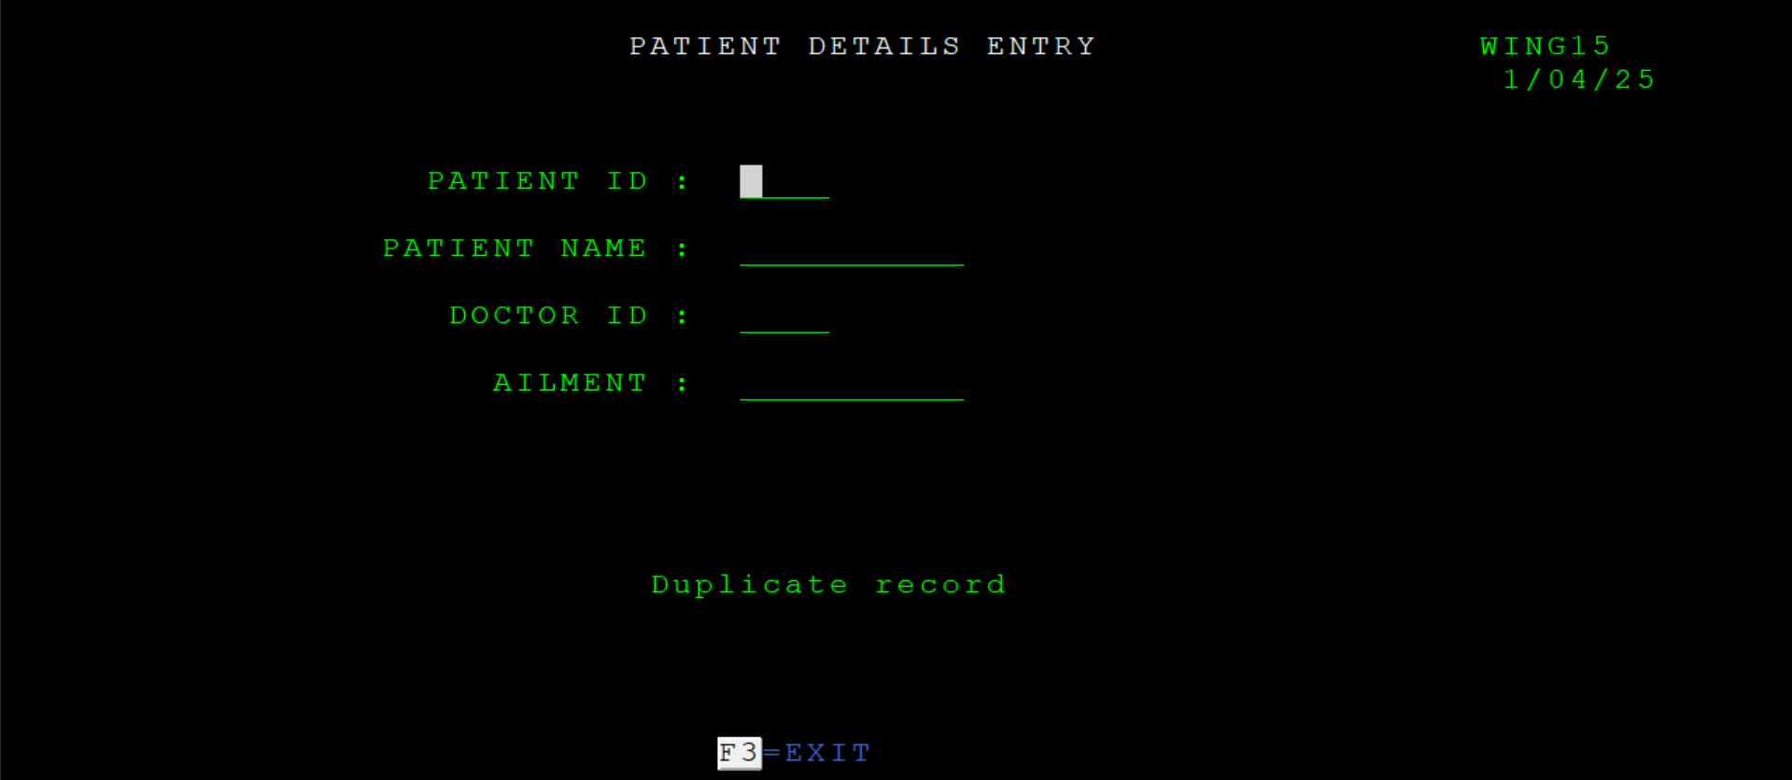

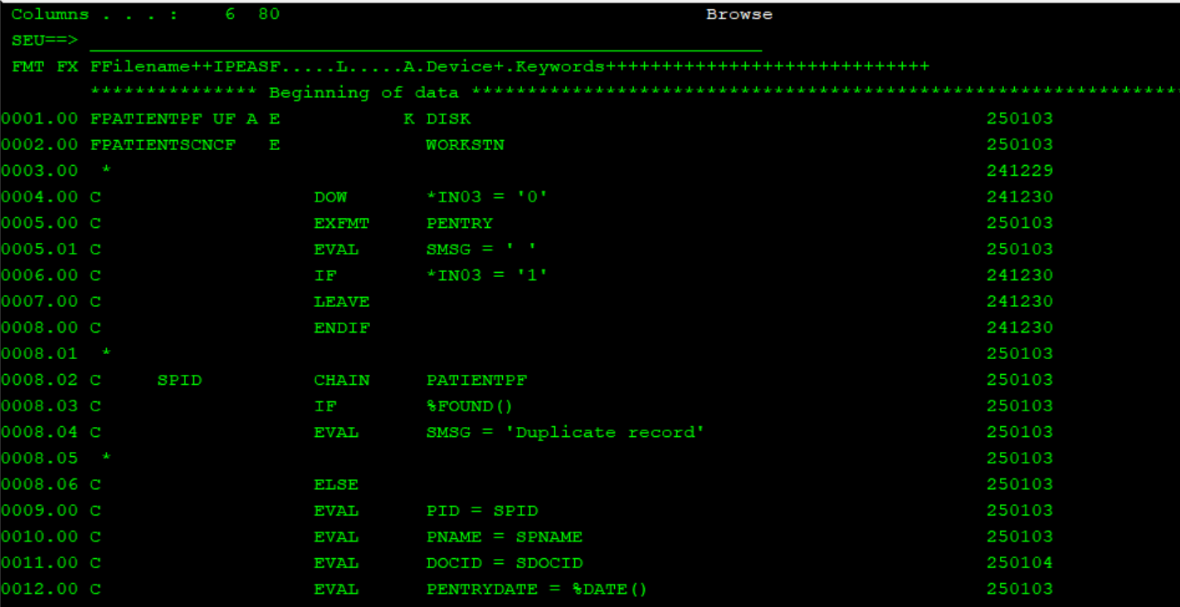

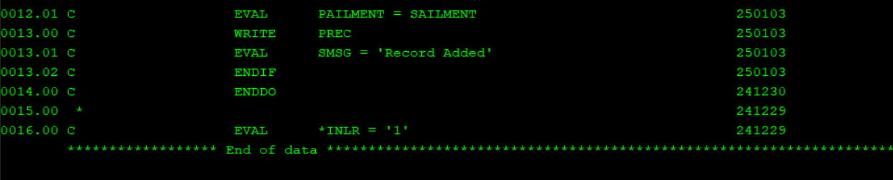

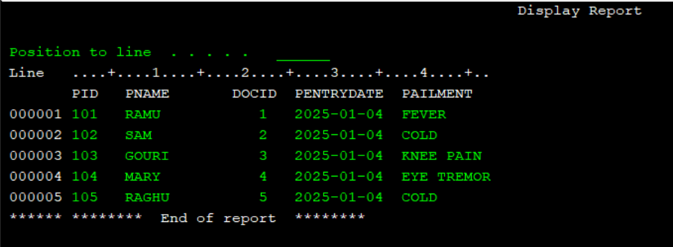

c. Create doctors pf with doctor id , doctor name ,specialty , doctors joining date as input.

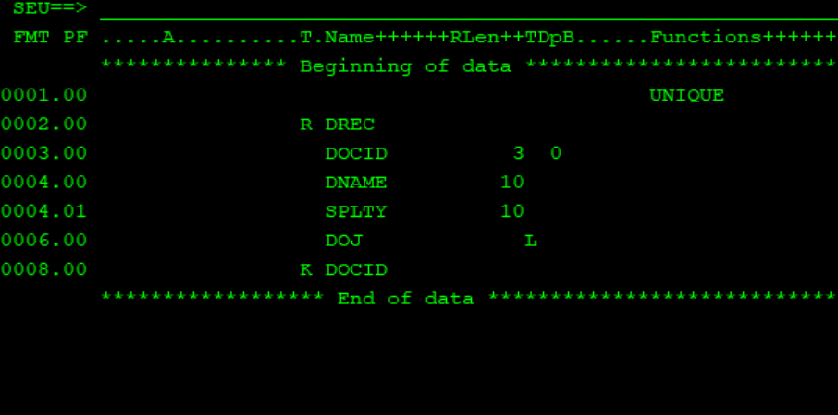

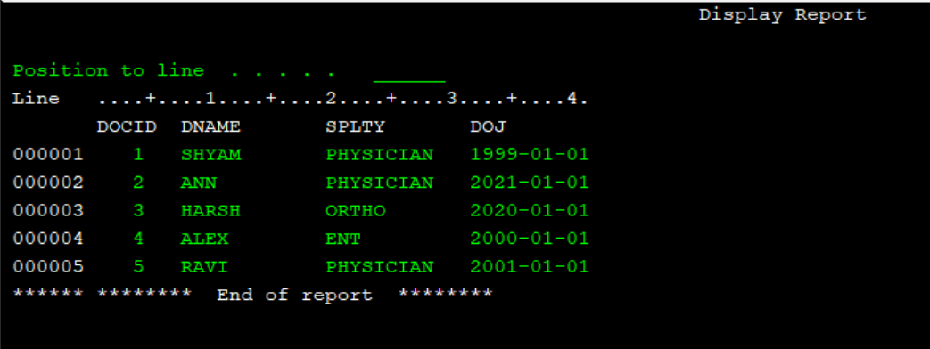

d. Create a join logical file on patient pf and doctors pf to display patient name , patient notes and attending doctors name.

